**Steps to Create APNS .p12 Certificate**

1. Login to  <https://developer.apple.com/membercenter/index.action>
2. Click on Certificates, Identifiers & Profiles

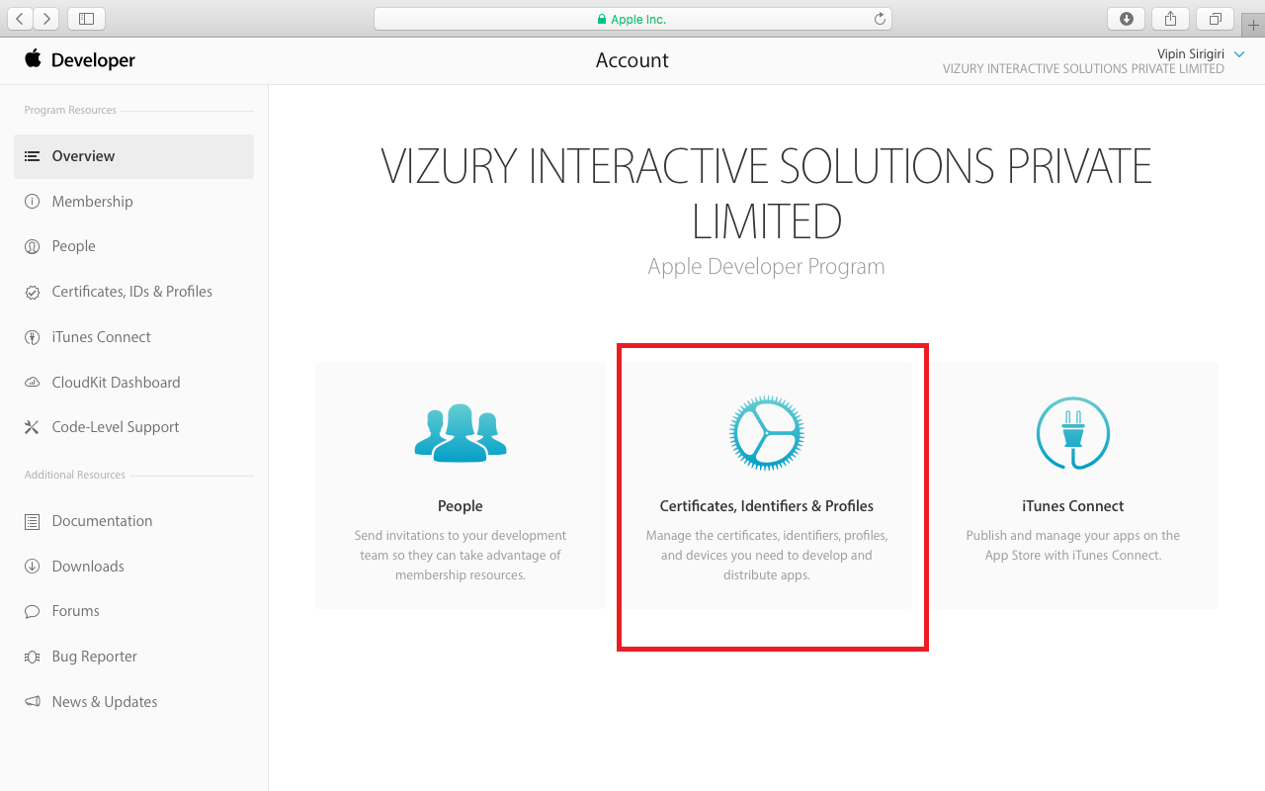

1. Go to Website Push IDs under Identifiers on the left-panel and click to Add a new certificate

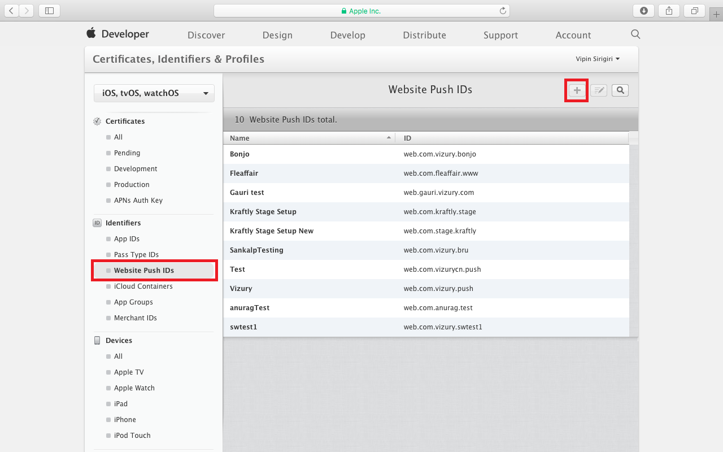

1. In Website Push ID Description enter your Website Name (Common Name)
2. In Identifier enter the reverse-domain name style for your website

(https://vizury.com Reverse-Domain Name -> web.com.vizury

https://www.vizury.com Reverse-Domain Name -> web.com.vizury.www)

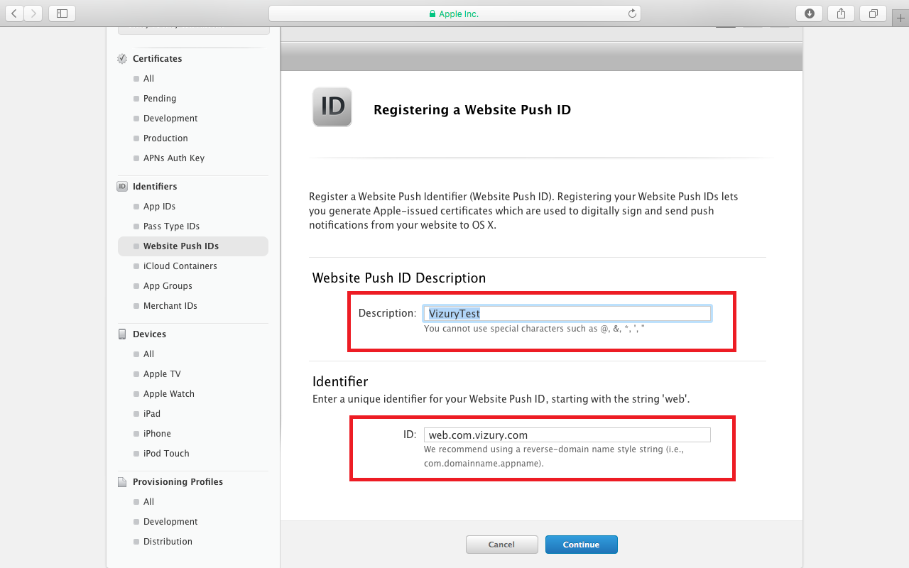

1. Select Continue and click on Next and Register
2. The created Push ID will now be listed under the Website Push ID section

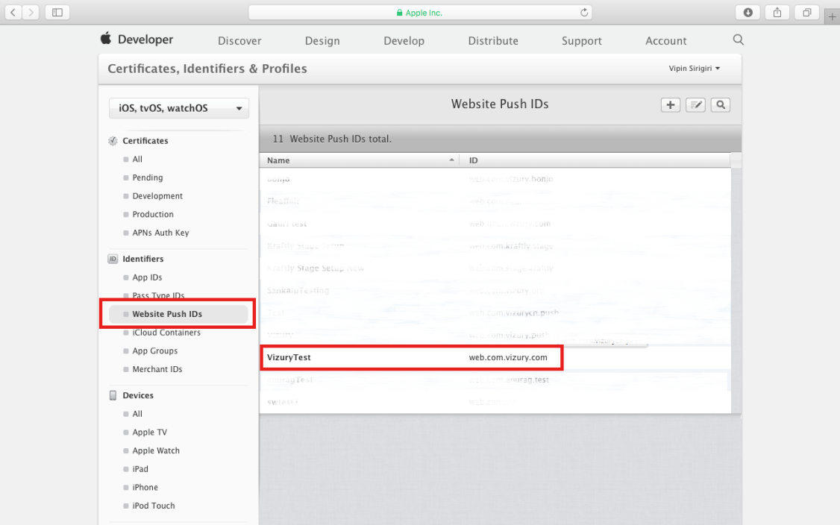

1. Select the created Push ID from the list, click on Edit and select Create Certificate

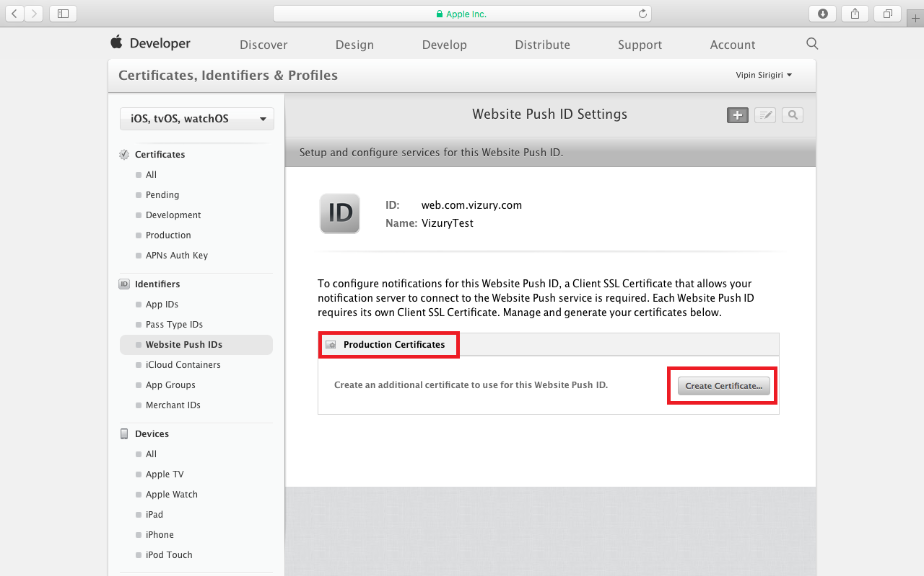

1. Follow the steps provided by Apple to create a CSR certificate

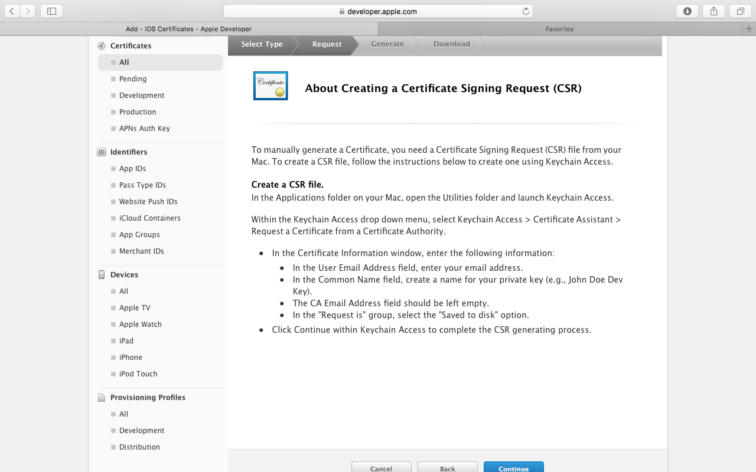

* 1. Go to Utilities Folder and Launch Key Chain Access
  2. Click on Key Chain Access Menu
  3. Select Certificate Assistant and then Select Request a Certificate from Certificate Authority

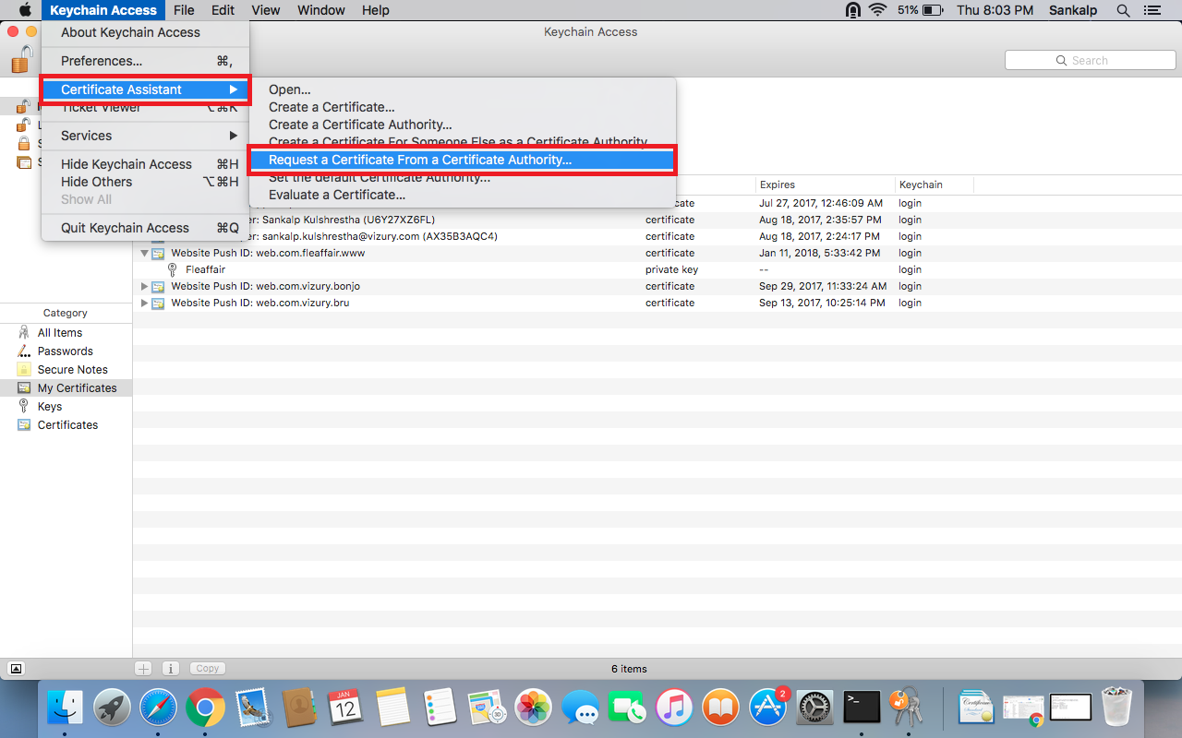

* 1. In the Certificate Information Pop-Up enter the User Email Id and Common Name
  2. Keep the CA Email Address Blank and select Request is Saved to Disk
  3. Click on continue and the CSR file will be saved to your Disk

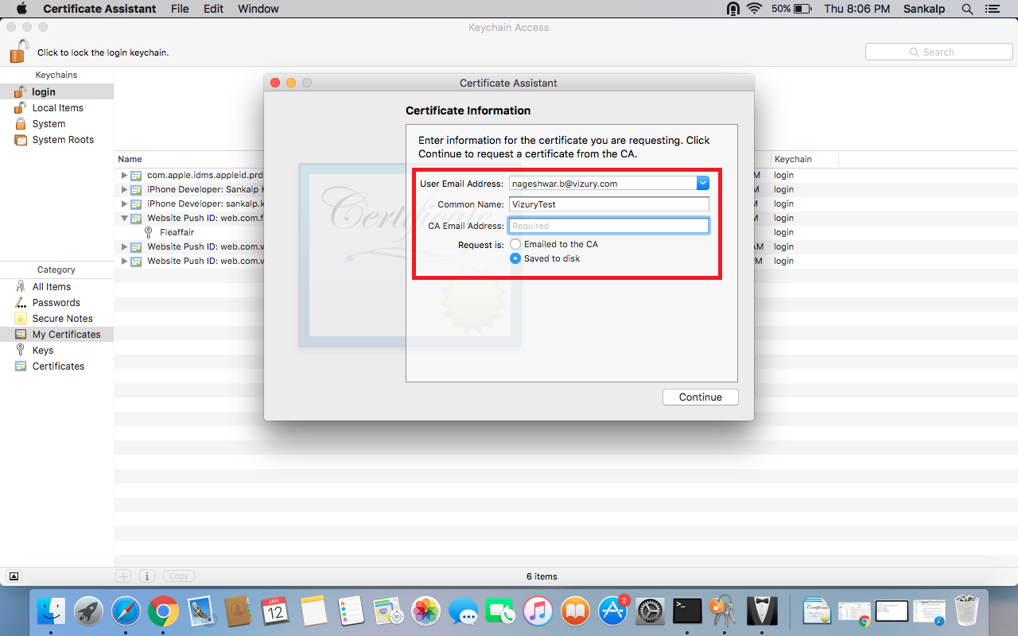

1. Once CSR (Certificate Signing Request) file is created, select continue on the IOS Certificate Window

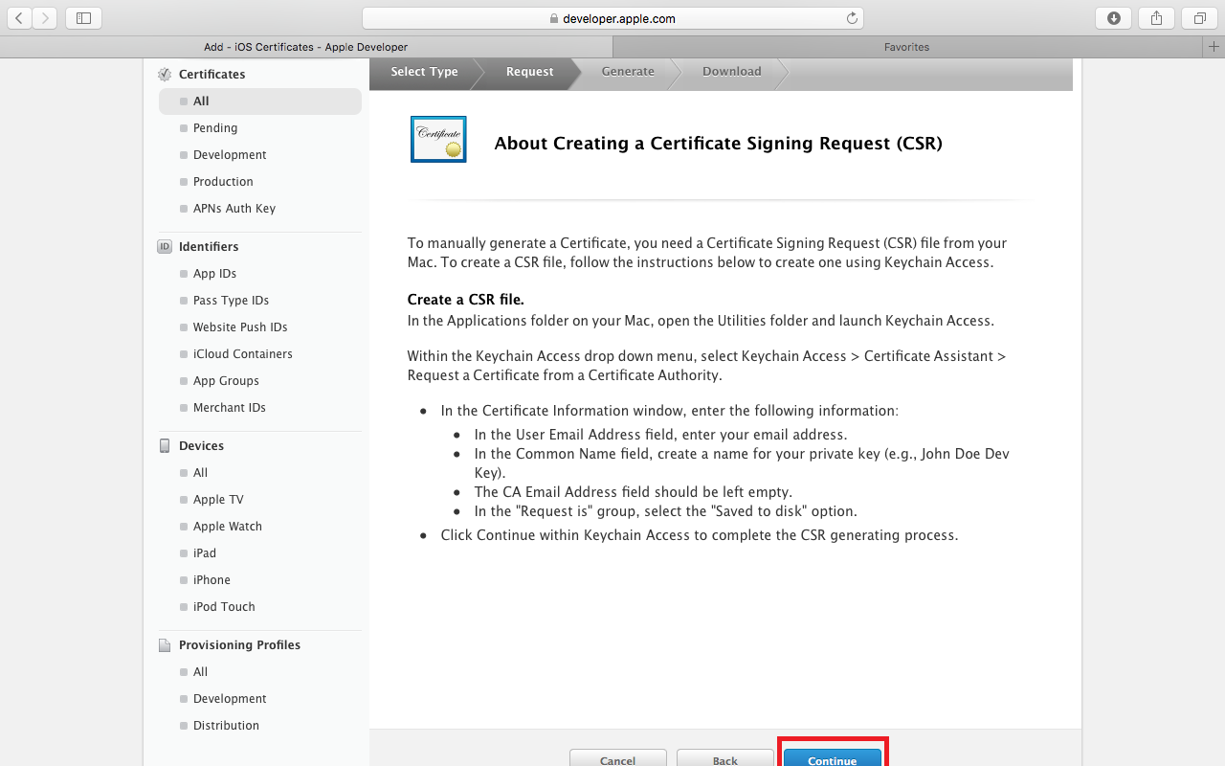

1. Upload your CSR file saved on your Disk and select continue

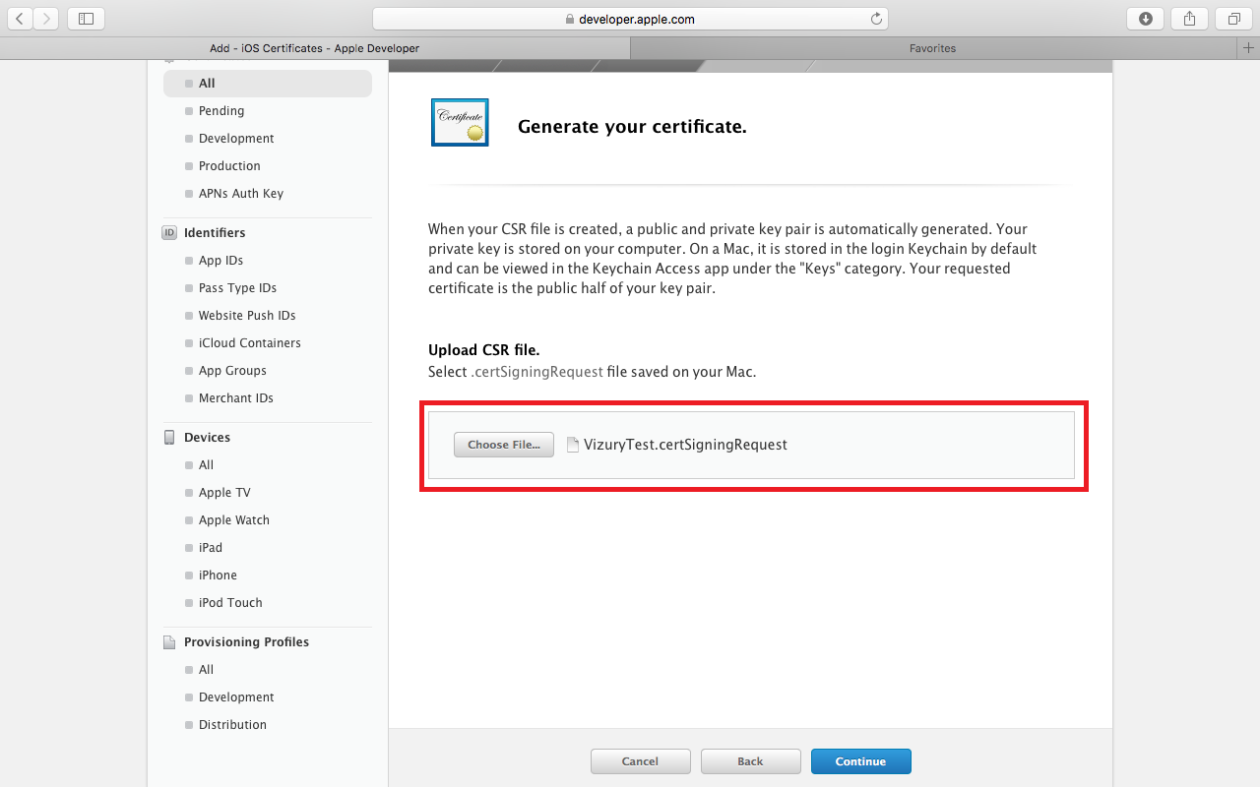

1. Download your certificate to your Mac, then double click the .cer file to install in Keychain Access

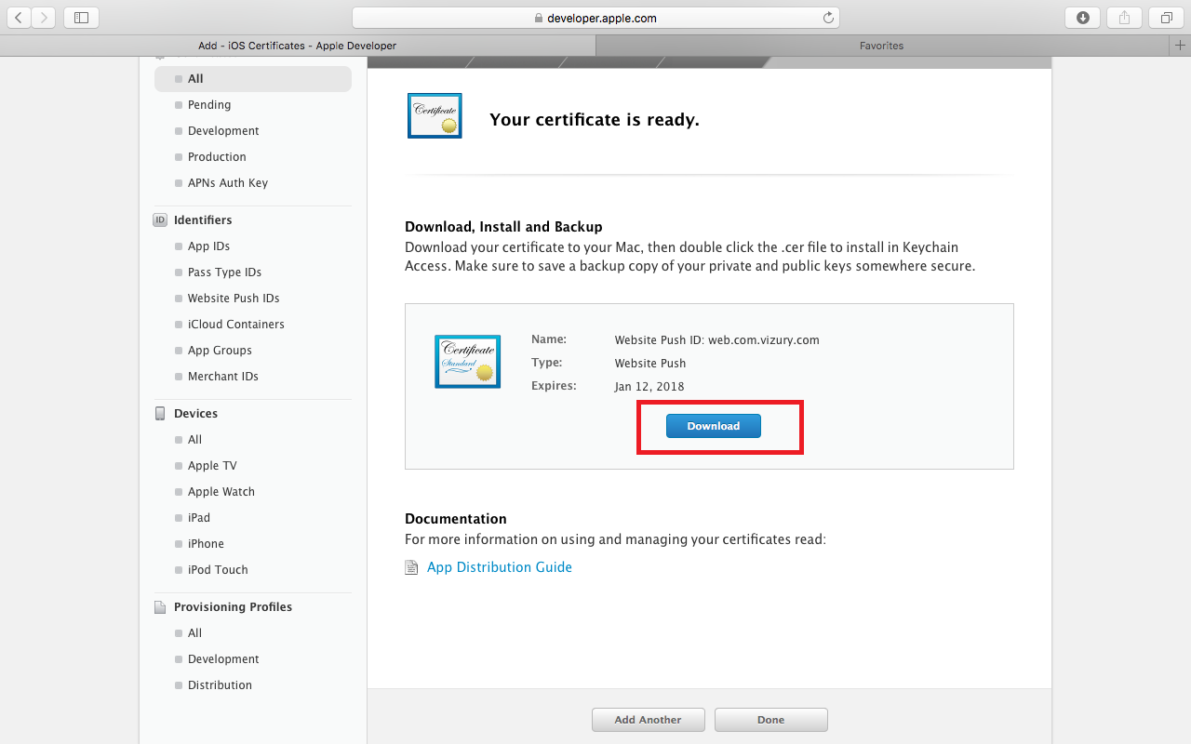

1. Go to Certificates, Find the certificate you just opened/imported in Keychain Access
2. Expand the certificate to show the Private Key
3. Select only the Private Key portion of the certificate and Right click
4. Click Export "Common Name" (Vizury Test) on the popup menu

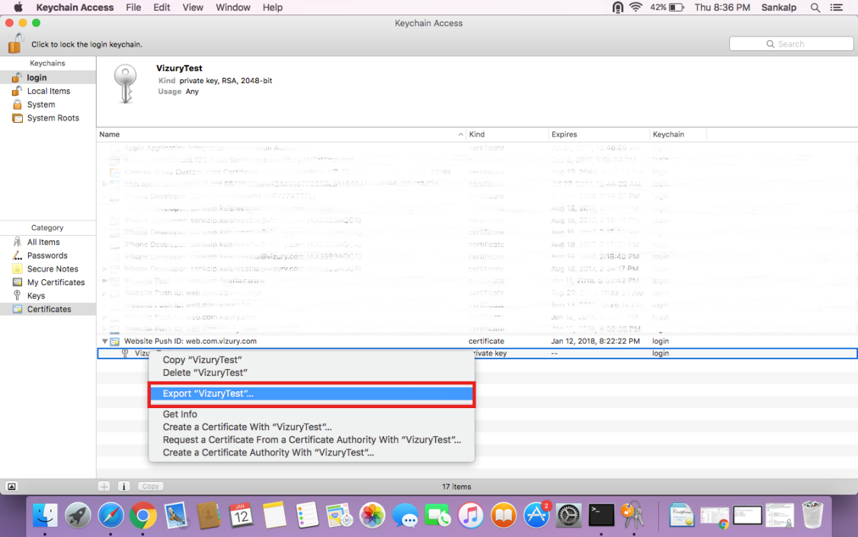

1. Choose a location and filename to export the .p12 file and click on Save

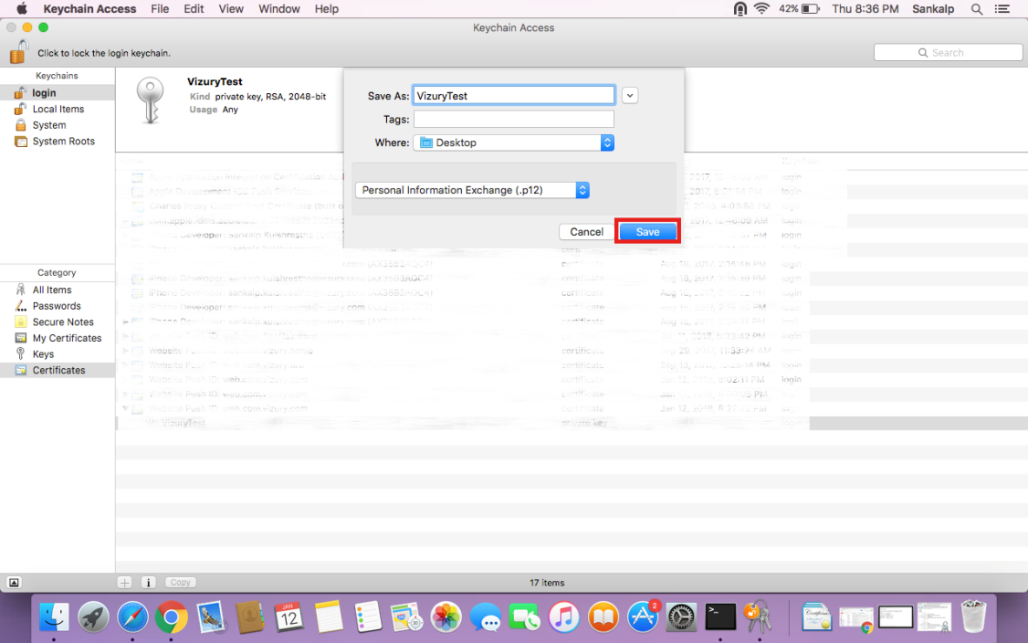

1. Enter a Password for the .p12 file to protect its private key contents and click Ok

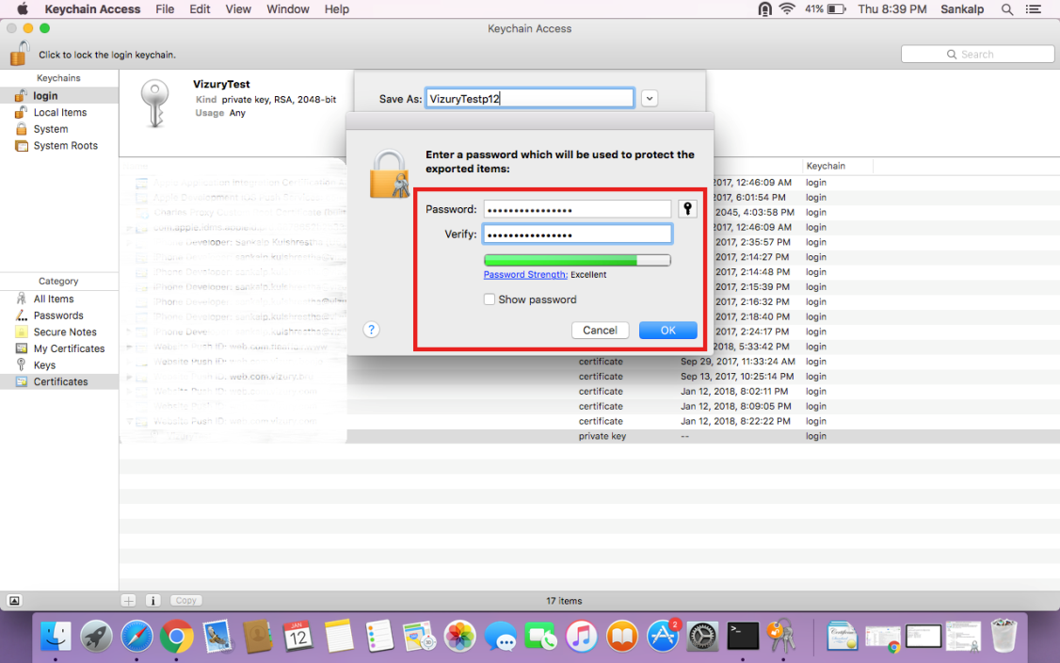

1. Make sure to save your Private and Public Key securely
2. Done! Now you have created the .p12 file to be uploaded in the Vizury Engage Commerce Platform